1st draft, 10/8/23.
President's Message, "Woburn and the Middlesex Canal"
Towpath Topics, Vol. 63, No. 1 (Oct 2023)

The water highway of the Middlesex Canal made possible rapid development of Middlesex County as shown in population growth recorded in the US census. The table below records that the Middlesex County grew 4x faster than Essex County between 1810 and 1820 and more than 2x times faster for the next 20 years.
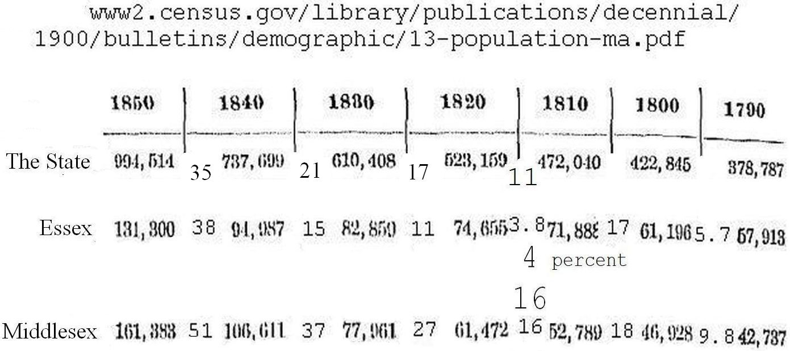
Population Growth of Essex and Middlesex Counties Compared.
One source of growth was the tanning industry in Woburn. Prior to low cost transportation, each farming village would have a tannery using the hides of local cattle and tanbark from nearby producing leather for local use.¹ Had bark from the forests of New Hampshire, cheap when delivered by boat, and hides from around the world delivered by boat to Boston. The brig Pilgrim, built in Medford in 1825, sailed to Mexico's California in 1834 to buy hides, a voyage described in the Harvard Classics book, Two Years Before the Mast by Richard Henry Dana, Jr. Woburn had the businessmen to build tanneries using the Middlesex Canal and water from Woburn's many brooks.² With leather produced in Woburn and later neighboring cities, Boston had become by 1935 the largest sole-leather market in the world.³ Massachusets likely became a shoe manufacturing center because the Middlesex Canal was the beginning of major leather manufacturing.
Notes.
1. "That is, there were no particular places in the United States where the tanning industry was centralized. There was no system of transportation whereby hides could be gathered from far and wide into one center, tanned, and shipped to the manufacturers of leather goods." Riley, George Archibald, "History of Tanning in the State of Maine" (1935), Page 27-134pdf. Electronic Theses and Dissertations. 2419. http://digitalcommons.library.umaine.edu/etd/2419
2. Woburn: A Leather City, a documentary by John McElhiney,
(6) Woburn: A Leather City - YouTube.
3. "Boston has the largest sole-leather market in the world". Riley, op. cit, page 87-134pdf.

