The Middlesex Canal Association

**Future Home of the Middlesex Canal Museum**

2 Old Elm St, North Billerica, MA

www.middlesexcanal.org

fundraising@middlesexcanal.org­­

978-670-2740

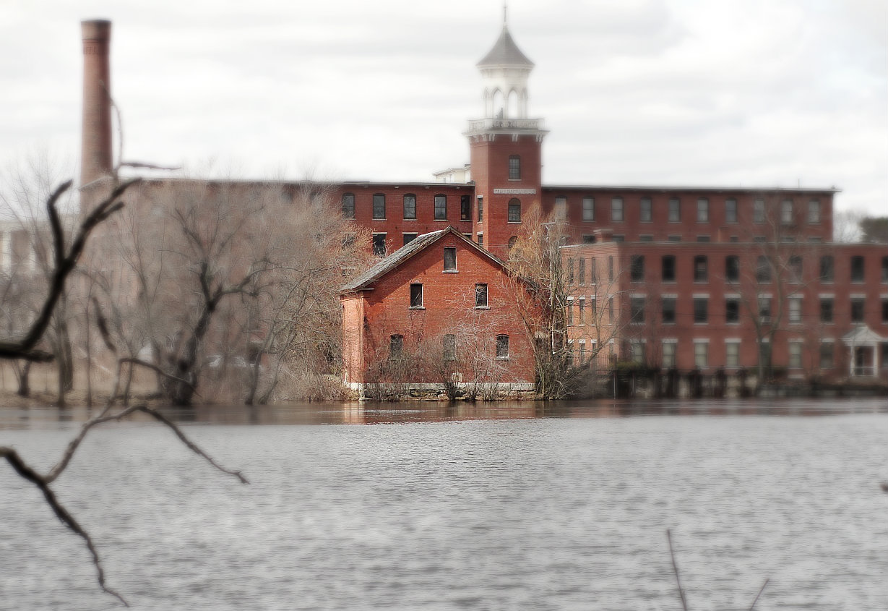

**Get Involved**

**Join our campaign**

**Become a member**

**Visit for FREE**

The Middlesex Canal Museum is currently across the street at 71 Faulkner Street in the Faulkner Mill

open Saturday and Sunday 12-4pm